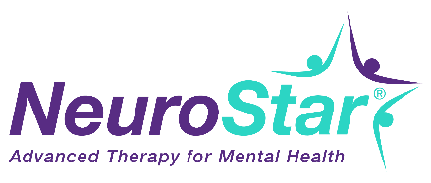
Health Care Professional Clinical Coordinator - Job Description
This newly created position will offer the opportunity to provide patient care with a breakthrough treatment modality for the treatment of depression. We are seeking an individual who will be trained to administer in-office therapeutic treatments under the direction of our treating physician. This individual’s primary responsibility will be to administer and manage the specific clinical services, interact regularly with patients and complete additional office administrative tasks when time provides.
Minimum Qualifications:  - Health Care Clinical Professional experience preferred but not required  - Two or more years of related experience in a customer or patient-facing role  Experience:  - Proficient in Microsoft Office with exposure to some data management software experience  - Experience addressing any patient’s medical conditions or symptoms, including basic life support certification  - Experience with operating a medical/mechanical device | Job Requirements:  - Strong communication skills  - Explain and administer procedures to patients  - Maintain a high degree of accuracy regarding all details  - Monitor a patient for medical symptoms  - Provide medical intervention in an emergency situation  - Contribute to a positive work environment  - Act courteously and with tact in dealing with patients, visitors and the public  - Maintain patient confidentiality  - Follow established treatment and office procedures  - Manage referral reporting and marketing programs  - Physically able to walk, stand, stoop, and bend  - Visual and auditory dexterity  Benefits: Our benefits include ….

SAMPLE AD FOR NEUROSTAR® COORDINATOR-

Wanted
Make a difference in patient care

We are looking for an individual who desires to make a difference in patient care with a breakthrough medical device for the treatment of depression. Health care experience is preferred but not required. The most important skill is communicating with patients and making them feel comfortable and safe. Strong attention to detail is required and the ability to follow a daily treatment checklist. This individual needs to be able to respond effectively in an emergency situation for patient care, possess strong listening and communication skills, be attentive to detail, and have the willingness to learn the use of a medical technology.

Our benefits include…..
Please contact…..

