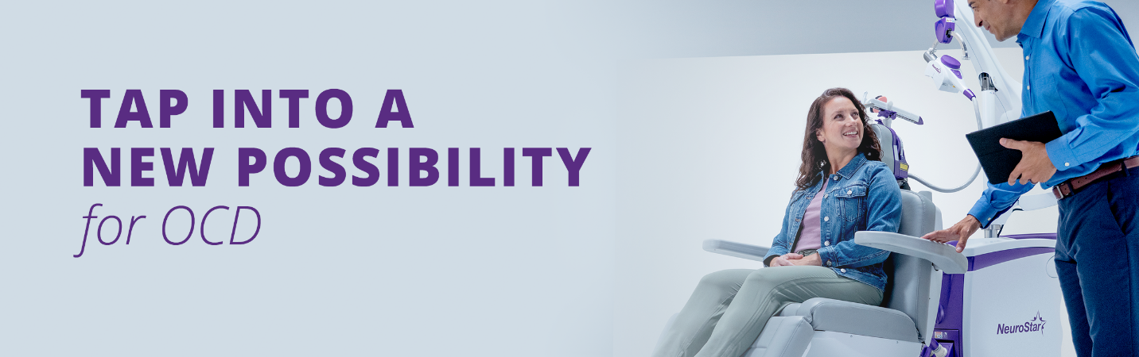Dear <Patient Name>,
Are you constantly feeling the need to clean or check things?
Do you sometimes have thoughts or urges you cannot get out of your head?
It’s normal to have occasional unwanted thoughts or urges. But for people diagnosed with obsessive-compulsive disorder (OCD), these thoughts can be frequent, intrusive, and upsetting. You may not realize that your obsessions and compulsions are excessive or unreasonable and potentially lead to impairment in your daily routine.
If you think you are struggling with OCD, and/or currently taking medication for depression/ anxiety, and not seeing an improvement in your symptoms, NeuroStar TMS may be a non-drug treatment option for you.
We offer free consultations for NeuroStar TMS.
To schedule a consult, call < XXX-XXX-XXXX>

Repeatedly experiencing unwanted thoughts can be extremely distressing and can interfere with daily life. Fortunately, we can treat OCD and help you manage your symptoms and improve your quality of life.
Give us a call to discuss your options.
<Practice Name>
<Practice Address / Logo >
_________________________
The NeuroStar Advanced Therapy System is indicated for the treatment of depressive episodes and for decreasing anxiety symptoms for those who may exhibit comorbid anxiety symptoms in adult patients suffering from Major Depressive Disorder (MDD) and who failed to achieve satisfactory improvement from previous antidepressant medication treatment in the current episode.
The NeuroStar Advanced Therapy system is intended to be used as an adjunct for the treatment of adult patients suffering from Obsessive-Compulsive Disorder (OCD).
The most common side effect is pain or discomfort at or near the treatment site. These events are transient; they occur during the TMS treatment course and do not occur for most patients after the first week of treatment. There is a rare risk of seizure associated with the use of TMS therapy (<0.1% per patient).
Visit neurostar.com for full safety and prescribing information.
53-55144-000 Rev A

