Subject: When Antidepressants Don’t Work - Drew Robinson’s NeuroStar Story
Preheader: Make sure you know all your depression treatment options.

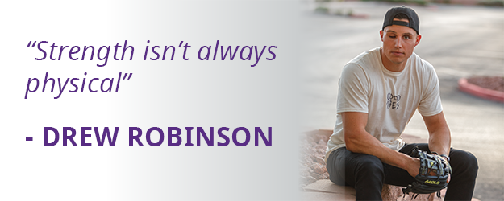

Drew Robinson was a rising Major League Baseball player until major depression derailed his career and his life. After trying multiple medications that didn't successfully relieve his depression, Drew felt hopeless. In the spring of 2019, he tried to take his life. Fortunately Drew survived. And during his recovery his doctor recommended a new possibility for treating his depression: NeuroStar TMS.

Today, Drew is a NeuroStar patient and mental health advocate, working to ensure people like him who suffer from major depression know all their treatment options, and can get the help they need. Click the link below to see Drew on the Today Show with Carson Daly talking about his journey with mental health!

WATCH THE SEGMENT

National Alliance on Mental Illness (aka. NAMI) also recently published a blog written by Drew called, “What I Wish I Had Known: We Don’t Have to Wait for a Crisis.”

READ THE BLOG

Antidepressants don’t work for everyone. And when they fail it can be hard to know where else to turn. NeuroStar TMS has helped thousands of people just like Drew experience relief and remission from major depression, without the systemic side effects of medications. If you or someone you care for suffers from depression, call our office today to schedule a free consultation, and see if NeuroStar TMS might be the possibility you’ve been looking for.

To schedule, call: <Practice Phone Number>

<Practice Name>
<Practice Address / Logo>
<Practice Website Link>

Check out Drew in the media:
The NeuroStar Advanced Therapy System is indicated for the treatment of depressive episodes and for decreasing anxiety symptoms for those who may exhibit comorbid anxiety symptoms in adult patients suffering from Major Depressive Disorder (MDD) and who failed to achieve satisfactory improvement from previous antidepressant medication treatment in the current episode.
The NeuroStar Advanced Therapy system is intended to be used as an adjunct for the treatment of adult patients suffering from Obsessive-Compulsive Disorder (OCD).
NeuroStar Advanced Therapy is only available by prescription. A doctor can help decide if NeuroStar Advanced Therapy is right for you. Patients’ results may vary.
Visit neurostar.com for full safety and prescribing information.

